**CLOUD FRONT**

S3 bucket created:

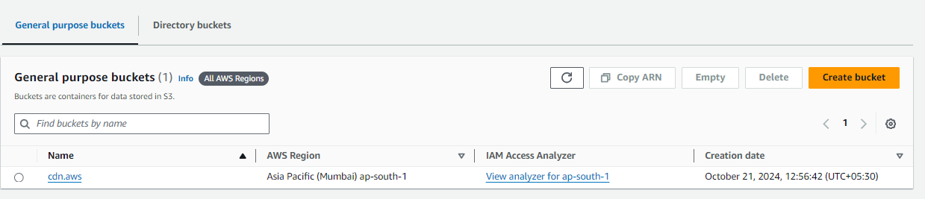

Object uploaded:

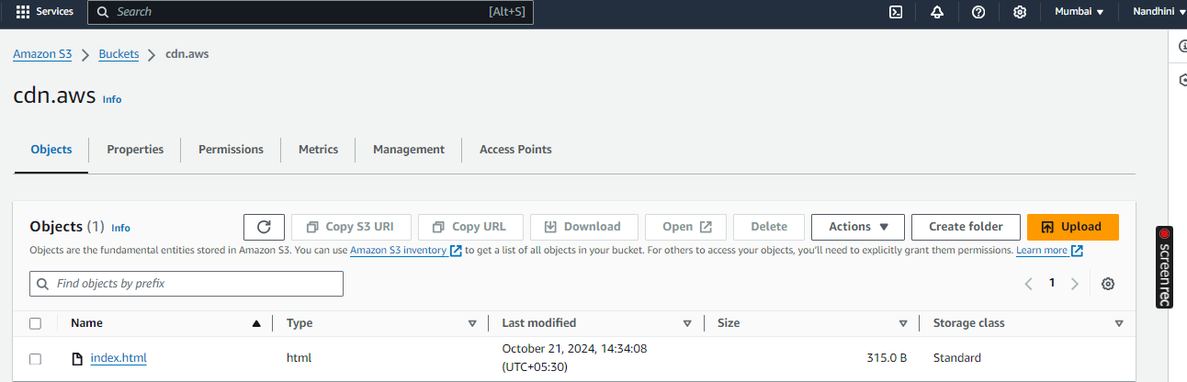

Enabled Static web hosting:

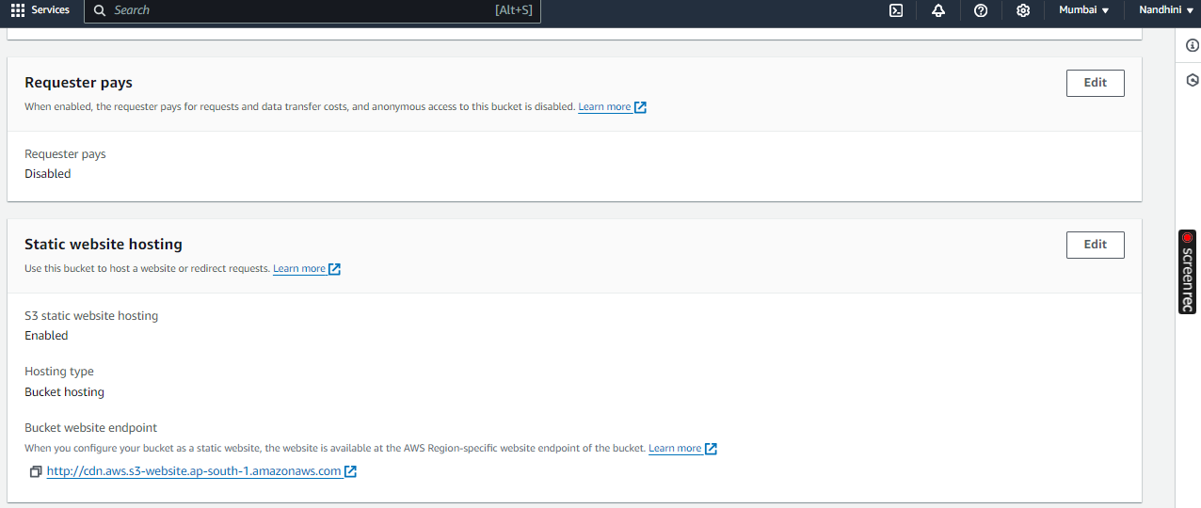

Distributors created in Cloud Front:

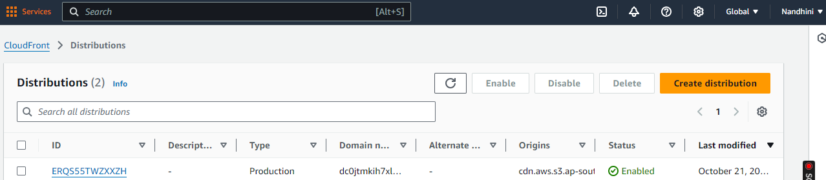

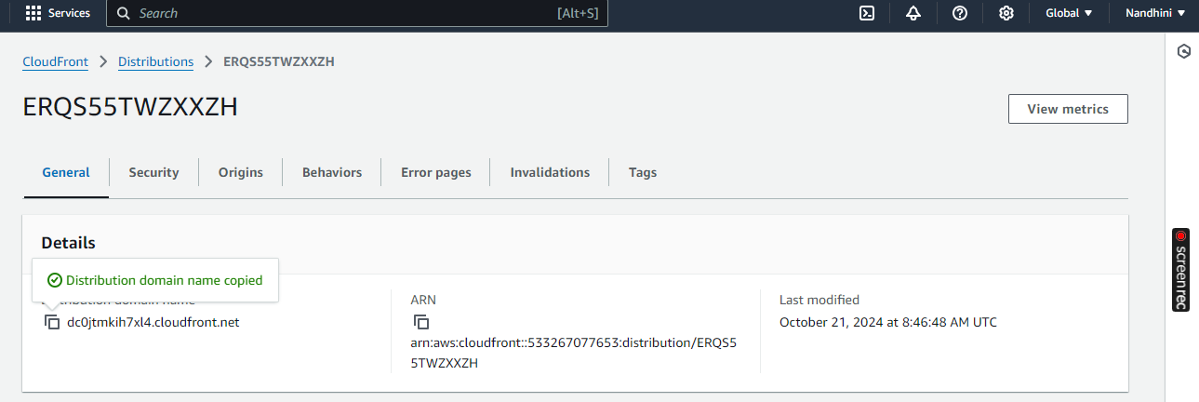

Distribution Domain Name:

